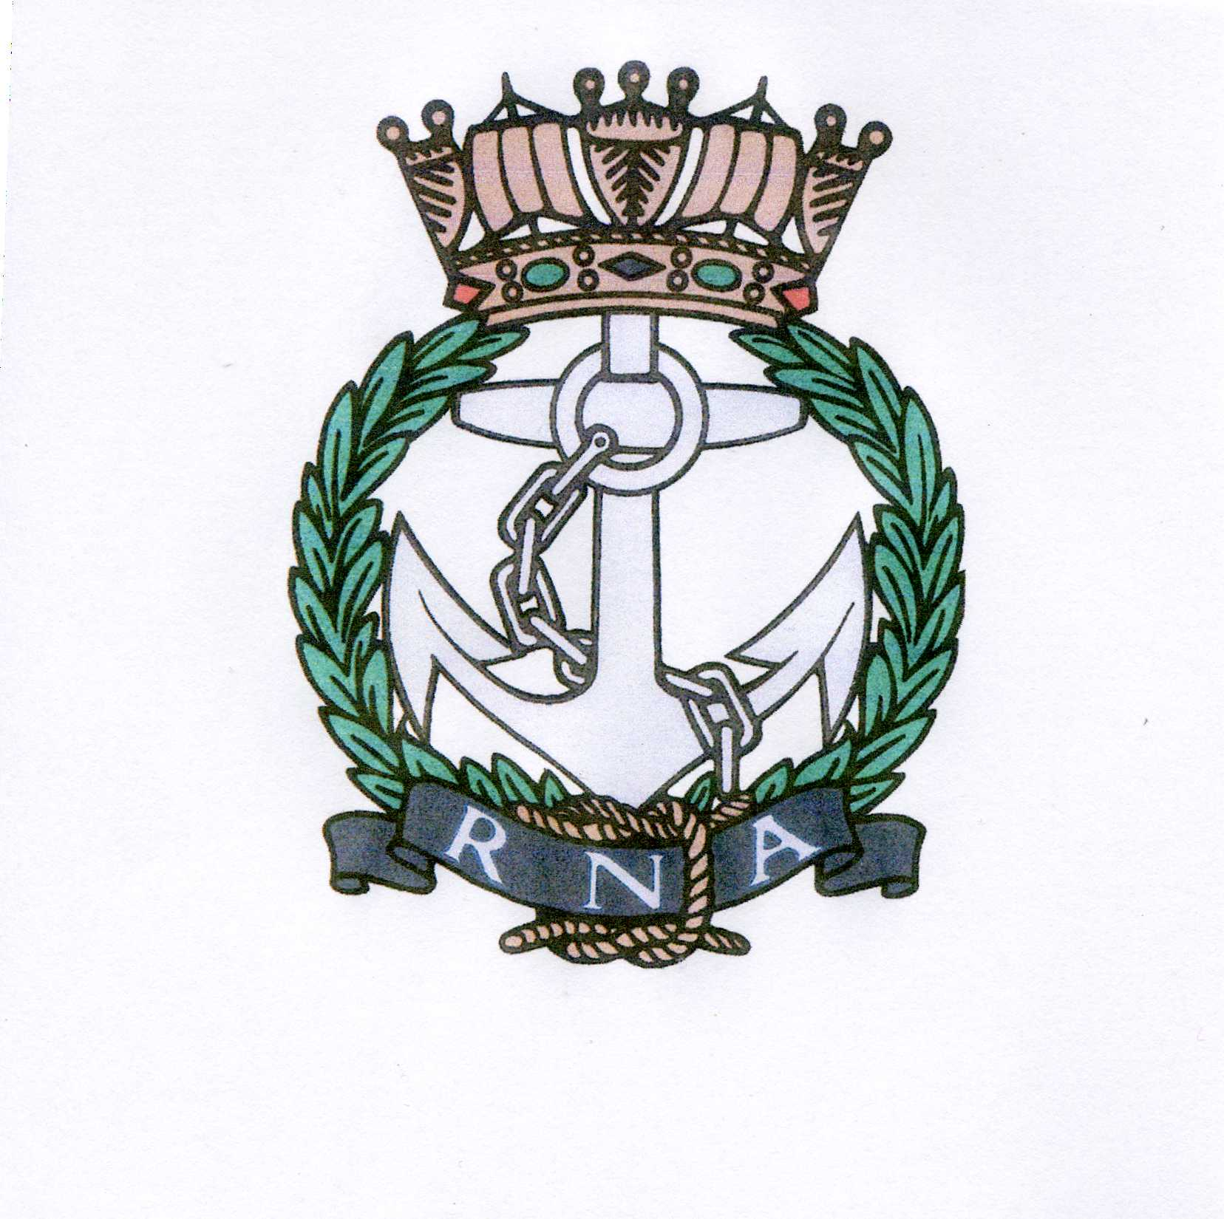
AQUITAINE BRANCH– ROYAL NAVAL ASSOCIATION
Chairman: Shipmate Ken Napier MBE
Chazarem, 47290 Beaugas
Email napier.chazarem@wanadoo.fr Tel 05 53 01 72 80

MINUTES OF THE ANNUAL GENERAL MEETING HELD AT LES VOYAGEURS,
BOUNIAGUES, 1100 ON 9TH JANUARY 2013

- MEMBERS PRESENT: Ken Ayling, Pam Ayling, Chris Barnacle, Pat Barron, Mike Beale, Terry Cattermole, Brian Chandler, Val Clarke, Chris Corner, Gervais Coryton, Rena D’Aubrey, Robin Faulkner-Smith, John Hudson, Brian Johnson, Henri Kastelein, Jeannette Kastelein, Tom Lecky-Thompson, John Mills-Baker, Mike Minter, John Murphy, Carolyn Murphy, Ken Napier, Sue Napier, Dave Pegg, Dave Rolfe, Liz Rolfe, Anne Scanlan.

- APOLOGIES: Alan Acland, Richard Amott, Joan Amott, Mike Brookes, George Carrington, Beverley Carrington, Ernie Coster, David Forsyth, Michael Frior, Antoinette Henry, Mike Holland, Geraldine Jackson, Jill Johnson, Frank Legg, Alan Lithgow, Gareth Mulloy, Don Pike, David Rollston-Smith, Patrick Sturges, Gerard Vauxion, Adrian Wallace.

- APPROVAL OF MINUTES FROM AGM 2012: The minutes of the previous AGM were approved. Proposed Dave Pegg, Seconded Mike Beale. Chris Barnacle asked that in future Minutes, numbers of members should be clarified.

- ELECTION OF COMMITTEE: The committee from 2012 were all willing to continue in their posts, except for John Murphy who wished to resign his post as raffle organiser. He is happy to continue as menu co-ordinator. The committee was re-elected as follows: Chairman Ken Napier, Vice-Chairman Ken Ayling, Secretary Brian Chandler, Treasurer Ray Pemble, Asst-Secretary Sue Napier, Asst-Treasurer Val Clarke. Ex-officio members: Welfare Pam Ayling, Standard Bearer and Library John Mills-Baker, Menus John Murphy, Committee Member Chris Corner. Proposed Terry Cattermole, Seconded Mike Beale.
Rena D’Aubrey volunteered to take on the raffle organisation with the help of Yvonne Massey. Rena was duly elected, proposed Pam Ayling, Seconded Brian Chandler.

- CHAIRMAN’S REPORT: The Chairman welcomed everyone. Membership on 31 December 2011 was 119, of which 69 were Full Members and 49 were Associate Members, plus the Chairman. On the 31 December 2012 there were 66 Full Members, and 42 Associate Members, plus Ken Napier as Life Member. Over the year we gained some new members and lost some – through death, Rosemary Thorpe, and through returnees to UK. The numbers include the group known as the Tender in the Poitou Charente. The Chairman pointed out that due to the first Chairman of the Tender returning to UK and the present Chairman having health problems in 2012, the Tender has had a quiet year. The returning of various members to UK and of those not intending to continue their membership has had a slightly detrimental effect on the ratio of FM to AM which should remain as near to 4:3 as possible. Hopefully we can redress the balance in 2013.
We had 11 monthly lunches and a very successful Jubilee Lunch. The average attendance at lunches over the year was 42. The Trafalgar and Christmas lunches were well attended. An extra lunch was held at Siorac de Riberac to accommodate our more northern members and we had a small lunch at Bordeaux for the Cockleshell Heroes commemoration in December. Lunches’ costs varied from 16 to 25 euros. The Chairman thanked those who had organised lunches this year.
The Standard was paraded in Bergerac on 8th May, in Monteton on 11th November and at the Cockleshell Heroes Anniversary. Wreaths were laid at Bergerac and at Bordeaux for the Cockleshell Heroes.
The Chairman thanked the Committee members for their support and work over the past year.

The monthly raffle takings were considerably up this year on last year. They are used for the many cards, flowers champagne etc that Pam Ayling our Welfare Rep organises. Our thanks to the estate of Rosemary Thorpe for the legacy of a generator, sold to benefit RNA funds by 300€. Please be sure to tell us if you have a special anniversary coming up or if you have been in hospital. There were no contributions to charity in 2012 as we had overdone it in 2011.The library, started from a bequest from a WWII seagoing ex-Wren, (most unusual) who served in the Atlantic, now has many valuable books. The library is only for Maritime themed books.
Our affiliated ship RFA WAVE RULER has been very busy since her work up, in the Indian Ocean. We have four officially affiliated serving men. RM Jack Lithgow completed a third trip to Afghanistan and is now doing junior officer training; Cdr Darren Houston moves from HMS DRAGON to be Chief of Staff of NATO’s Maritime Operational Group 1, soon to be in the Indian Ocean. We also have Alex Meyer who has left the Appointer’s Office and will do XO courses in Feb and then joins HMS DIAMOND. Capt Nigel Budd, Capt and Owner of RFA GOLD ROVER, Falklands Islands, is the 4th. We are now also officially affiliated with the French frigate AQUITAINE, which has been accepted into the French Navy and is doing trials.
The RNA HQ monthly newsletter is now published on the Internet.
The Chairman thanked everyone for coming along.

- TREASURER’S REPORT: There was only an interim audit done as the Treasurer is away. A full and final audit will take place in February. The raffle income increased by 470€; the current account stands at 2631 € and the Livret A at 2118.38€. The Treasurer recommended that we could give 2500€ to charity this year.
The auditors commented that the books were very well kept.
The interim report was approved Proposed Ken Ayling, Seconded Brian Chandler.
The auditors for 2013 will be Dave Rolfe and Mike Beale.

- ALLOCATION OF FUNDS: It was proposed that the 2500€ be distributed 4 ways. 800€ to the RNBT, 700€ to ARNO, 500 € each to the WRNSBT and to SSAFA.
Proposed Chris Corner, Seconded Pat Barron

- RNA WEBSITE: Brian Johnson, an Associate Member, offered to set up and administer an RNA Aquitaine website. He had produced a sample site. The members present were all in favour but it was decided there would be no blog sites. All items for the site should be sent to the Chairman. The address will be published in due course.
Liz and Dave Rolfe offered to pay for the cost of the name for the first year.
The Chairman proposed a vote of thanks to Brian for the work he has put in on the site – and will put in, in the future, and to Liz and Dave Rolfe for their kind offer. (Late news: the site is now up and running, www.rna-aquitaine.com but not for blog type entries).

- SOCIAL PROGRAM: The 8th of May is the 2nd Wednesday of the month and a public holiday. Because many people like to attend their local 8th May ceremonies the May lunch will be changed to the 15th May in 2013. Our standard will be paraded on the 8th May 2013.
The Trafalgar lunch will be on Sunday 20th October 2013.

10. MARINER’S TALES: The Chairman thanked all those who had so far contributed and
encouraged others to do so.

11. ANY OTHER BUSINESS: there was a request that members email addresses be added to the
Members Address list. This was vetoed by the members present.

Pam Ayling proposed a vote of thanks to Ken and Sue Napier.

The meeting closed at 1208.

.

